Network Traffic Analysis Using Wireshark

Network traffic analysis is a crucial component of cybersecurity and network management. Wireshark, a widely used network protocol analyzer, enables users to capture and inspect data packets flowing through a network

Users must select the network interface they wish to monitor, such as Ethernet or Wi-Fi.

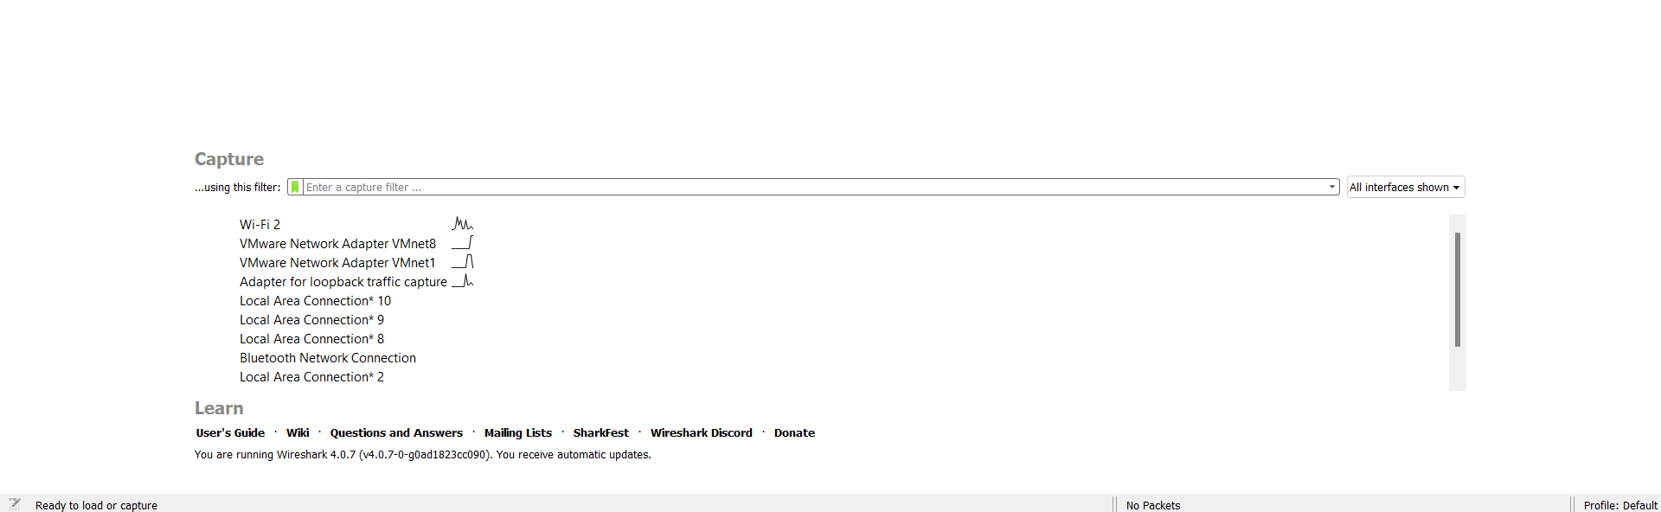

Once data packets are being captured, users can leverage Wireshark's powerful filtering options to focus on specific traffic types. The filter feature is accessible via the display filter bar at the top of the interface. By entering criteria such as IP addresses, protocols (e.g., HTTP, TCP), or port numbers, users can hone in on relevant packets. For instance, entering “ip.addr == 192.168.1.1” filters the view to display only incoming and outgoing traffic related to the specified IP address, thereby simplifying the analysis process.

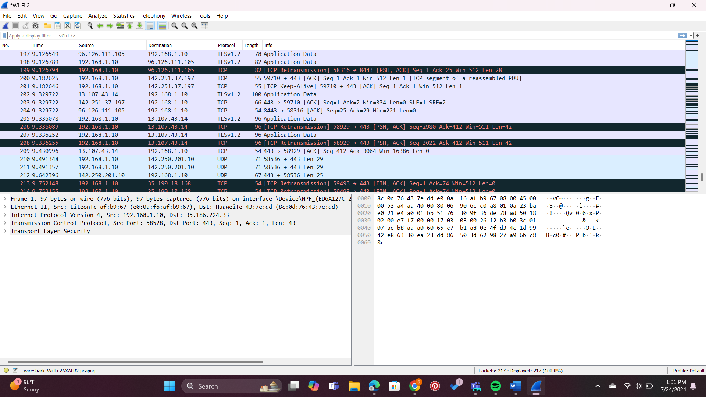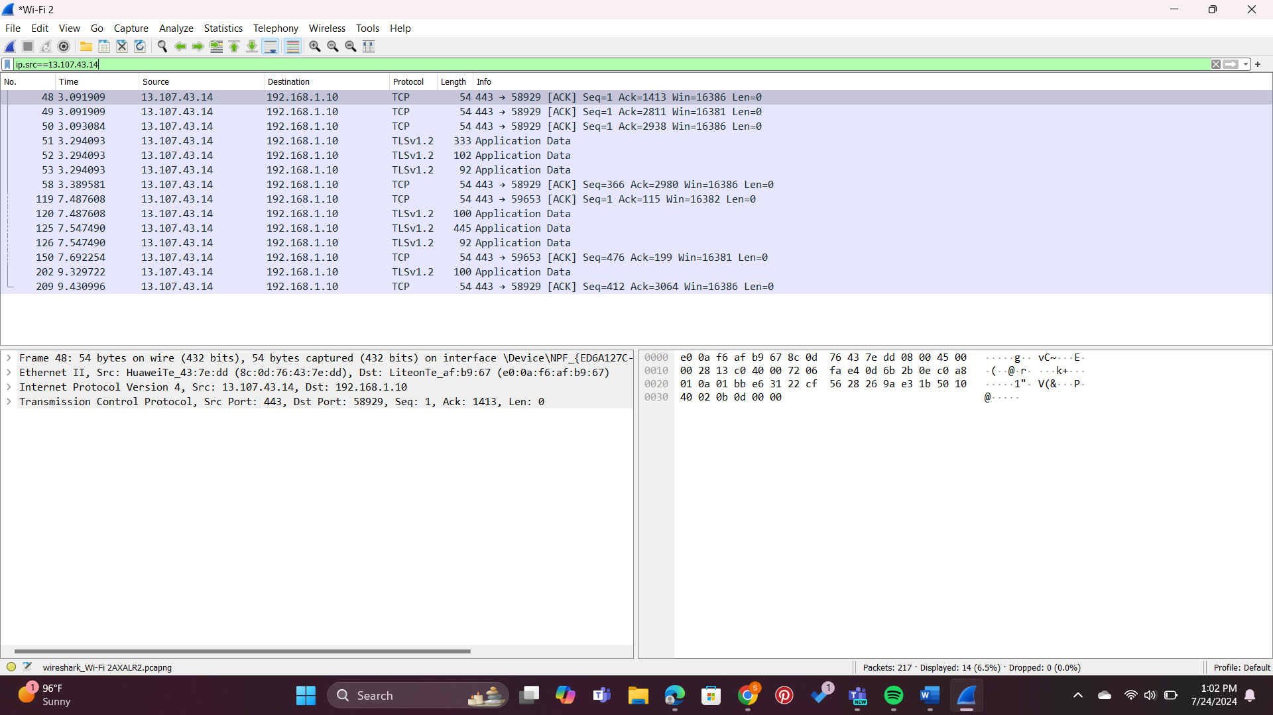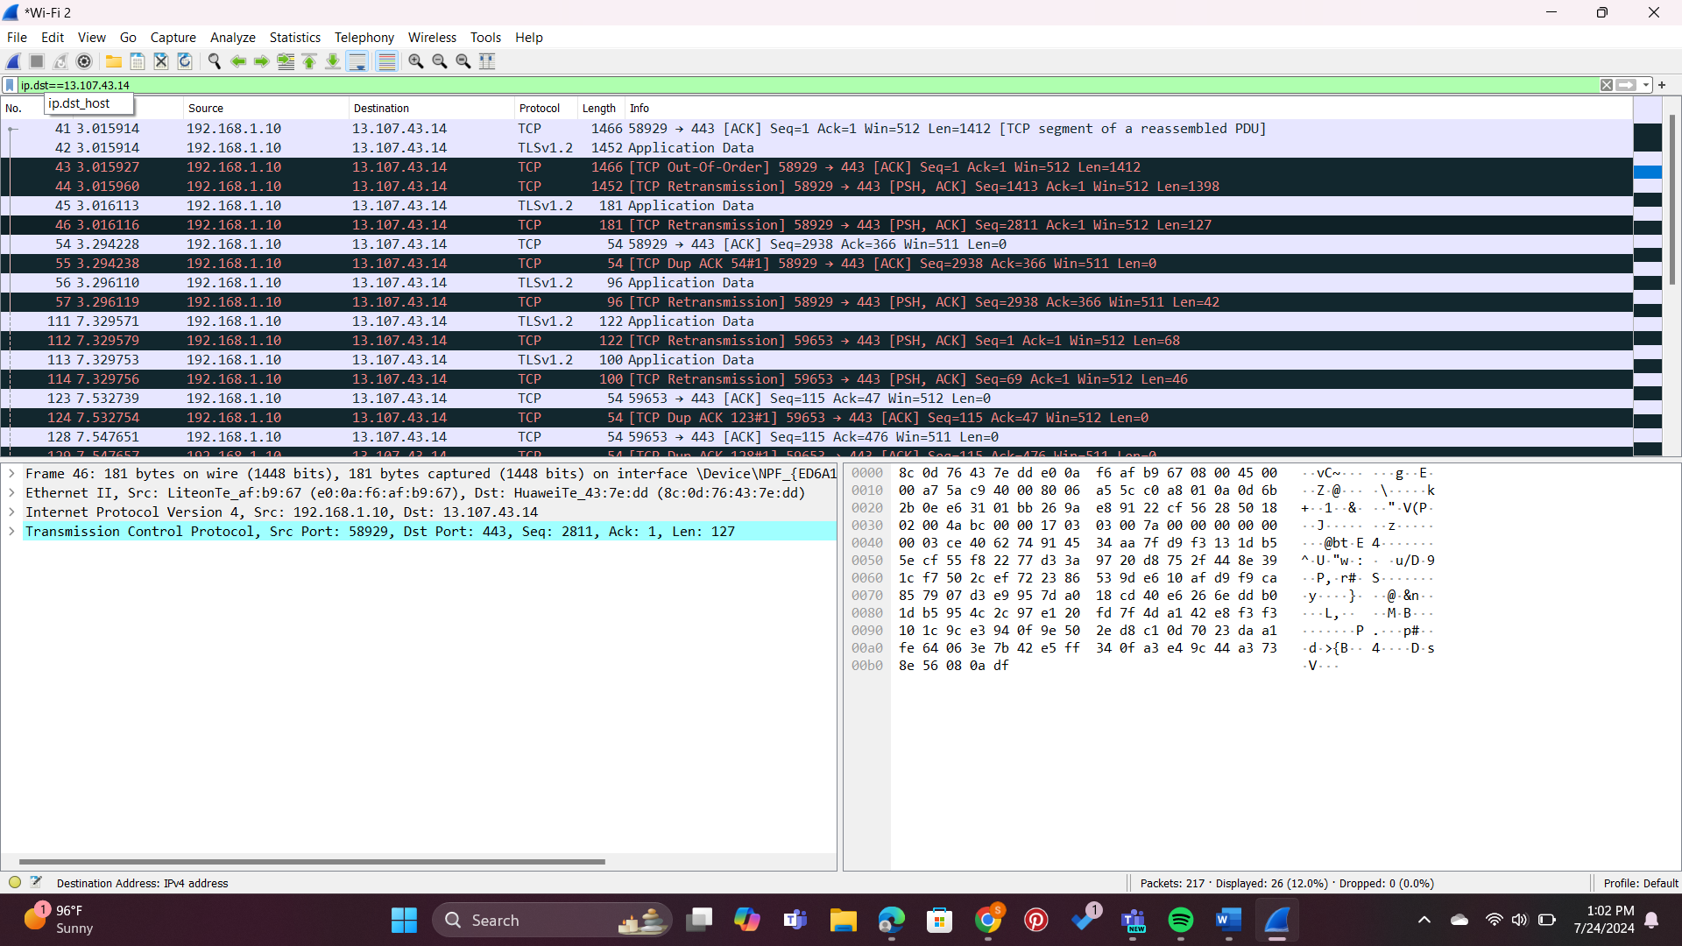

when suspicious IP addresses are identified, it is prudent to verify their legitimacy. VirusTotal or Talos serves as an invaluable tool in this regard. By visiting the VirusTotal website , users can enter an IP address into the search bar, which then aggregates data from multiple threat intelligence sources. The results provide insights into whether the IP address is associated with malicious activities, thereby informing subsequent security measures.

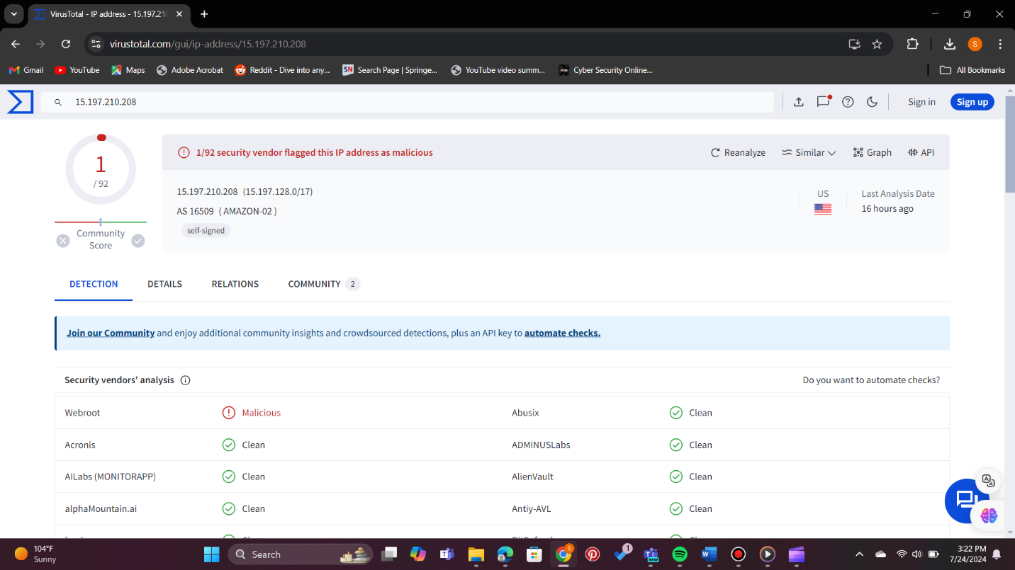

Suspicious network activity refers to unusual or abnormal behavior observed within a computer network that may indicate a potential security threat. This can include unauthorized access attempts, unusual data transfers, communication with known malicious IP addresses, or deviations from established patterns of normal network behavior.

Suspicious network activity can be a precursor to various cyber threats, such as malware infections, data breaches, or network intrusions, making it essential for organizations to have robust cybersecurity measures in place to detect and respond to such anomalies effectively.

Security systems and tools, such as intrusion detection systems (IDS) or firewalls, actively monitor network traffic for anomalies and generate alerts when suspicious activity is detected. Promptly investigating and addressing these alerts is important for identifying and mitigating potential security breaches.

Examples of suspicious activities:

**Malicious Database Activity**

Unauthorized internal or external changes to the database can cause suspicious activities to pop up. You can identify these activities through changes in users, permissions, and content.

**Abuse of User Accounts**

Privileged account abuse signals potential insider threats. Look for altered audit trails, shared account access, and unauthorized access to sensitive data as key indicators of such security breaches.

**Change in User Access**

Unusual alterations in user access patterns often indicate external threats, like hackers exploiting user credentials to breach your network. Watch for anomalies such as off-hour or remote logins, repeated login failures, and inconsistencies between a user’s profile and the associated device, as these may signify security risks.

**Configuration Changes**

File configuration alterations—replacing, modifying, adding, or deleting—are clear indicators of a data breach. These changes suggest unauthorized network access, revealing an attempt to operate discreetly within your system and emphasizing the potential compromise of sensitive information.

**Abrupt Network Changes**

Unusual external infiltration attempts manifest in atypical traffic origins, targets, protocol breaches, erratic network performance, and unauthorized scans. Watch for these signs to detect potential security threats and safeguard your network against unauthorized access or compromise.

**End Users Detecting Changes**

In smaller organizations with limited security measures, end users often observe the initial impacts of suspicious activity. Signs may encompass increased pop-ups, unusual antivirus notifications, sluggish device or network performance, and the appearance of unauthorized toolbars. Stay vigilant to empower users in recognizing and reporting potential security threats.

**How To Prevent Suspicious Network Activity**

### Know Your Data

To protect your data effectively, start by understanding its nature, storage location, access methods, and ownership. Classify data based on sensitivity, value, and regulatory compliance, implementing tailored security measures for each category. Map data flows, pinpoint dependencies, and identify vulnerabilities within your data architecture. This proactive approach enables you to apply precise security policies, ensuring a strong defense against potential risks.

### Monitor Activity

Ensure data security by routinely monitoring activity logs and metrics. Employ tools that collect, aggregate, and analyze data, alerting you to abnormal or suspicious events. Utilize cloud-native or third-party solutions for tracking user authentication, data access, transfers, changes, and anomalies. Regularly review activity reports and dashboards, promptly investigating any incidents or alerts. This vigilant monitoring enhances your ability to detect and respond to potential security threats efficiently.

### Implement Security Measures

Secure cloud data by deploying preventive measures. Employ encryption, masking, or tokenization for data protection in transit and at rest. Implement firewalls, network segmentation, and VPNs to secure networks and communication channels. Utilize identity and access management, multi-factor authentication, and role-based access control to regulate user access and privileges, ensuring robust safeguards against unauthorized actions.

### Update Policies

Regularly update policies to align with current architecture and needs. Review and revise data governance, quality, security, and privacy policies to meet business objectives, legal obligations, and industry standards. Communicate and enforce policies organization-wide, offering training and awareness programs for staff and stakeholders to promote compliance and understanding.

### Audit for Compliance

Periodically audit your cloud data security using internal or external auditors and automated tools. Assess and verify data security and privacy practices, using benchmarks and feedback to enhance maturity and effectiveness. Document and report audit results, showcasing accountability and transparency in aligning with benchmarks, indicators, and recommended improvements.

### Make Use of Experience

Adapt to the evolving landscape by learning from experience. Leverage lessons learned, best practices, case studies, and research findings to enhance cloud data security knowledge. Stay aware of emerging technologies and trends to optimize data architecture and security solutions. Implement feedback loops, continuous improvement, and change management to refine and update data security and privacy strategies, ensuring adaptability and effectiveness.